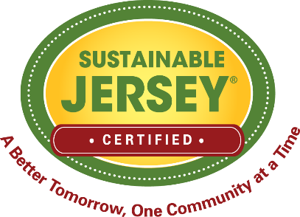 | Sustainability Hero Submission Form | 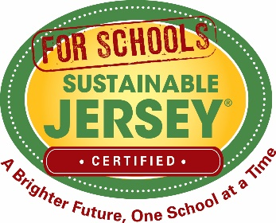

To capture the inspiring stories of our local leaders, we recognize a monthly Sustainability Hero. The hero should be someone who significantly contributes to advancing sustainability initiatives in collaboration with a municipal or school Green Team and/or by serving on a Sustainable Jersey Task Force. Please fill in the fields below and email your submission form to info@sustainablejersey.com

Nominee Contact Information
Name:
Phone Number:
Email:

Nominee Affiliation (check all that apply)
- Green Team Member (list municipality/school and position if applicable):
- Sustainable Jersey Task Force (list task force):
- Other:

Please submit a paragraph describing how your nominee has contributed to advancing sustainability.

