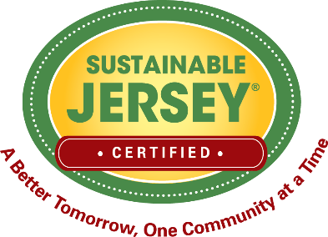
Grant Application
Proposed Project Action Plan
Please use this form to outline the specific steps or tasks needed to complete the proposed project. These steps include project planning, implementation, community outreach and evaluation. Identify the target completion date for each step to ensure the project can be accomplished by the end of the performance period. Include plans for ribbon cutting ceremonies and milestone events. Implementation steps should NOT begin until after the grant is awarded at the press announcement event. Additional lines can be added.
Steps/Tasks that the Project Team will take to Complete the Proposed Grant Project | Team Member Responsible | Target Completion Date
Planning Steps
1.
2.
3.
Implementation Steps
1.
2.
3.
Community Engagement Activities
1.
2.
3.
Evaluation and Reporting Steps
1.
2.
3.

Project Promotion – Events Where Promotional Materials With Sponsor Recognition Are Distributed
Name of Event | Materials | Date
1.
2.
3.
Proposed Date of Ribbon Cutting Ceremony (if applicable)

