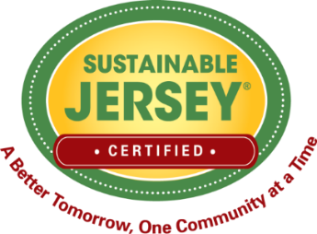
Grant Application
Proposed Project Action Plan
Please use this form to outline the specific steps or tasks needed to complete the proposed project. It should begin with the key planning tasks and end with project evaluation and completion of the final grant report. Per the terms of the grant, the project needs to be completed within the grant performance period.
Steps/Tasks that the Project Team will take to Complete the Proposed Grant Project | Team Member Responsible | Target Completion Date
Planning Steps
1.
2.
3.
Implementation Steps
1.
2.
3.
Evaluation and Reporting Steps
1.
2.
3.

