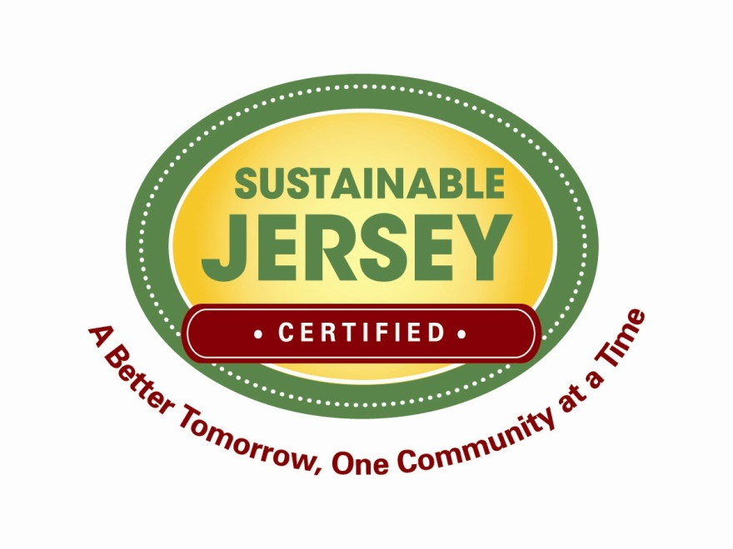

Green Development Checklist

Revised March, 2012

MODEL GREEN DEVELOPMENT CHECKLIST

This Model Green Development Checklist has been prepared to assist communities in encouraging and reviewing planning submittals for sustainable green design aspects. Current planning criteria frequently do not address these issues; therefore, they may not be considered in the formal approval process. However, it is beneficial for the reviewers to have a comprehensive understanding of the development’s sustainable aspects and its impact on the community. The review is organized by scale from regional context, to individual site, to the structures on the site.

The Model Green Development Checklist is organized into three sections:

1. First, it addresses the site within its regional and local context, looking at its physical location, development status, connectivity to infrastructure (transportation, community, green space) and beneficial and detrimental impacts within the regional or local context.

2. Second, it addresses the site itself, looking at the beneficial or detrimental impacts of the development on site.

3. Third, it addresses the structures on the site, again looking at beneficial or detrimental impacts.

As mentioned earlier, many green design aspects overlap. The handling of rainwater impacts the regional water supply and treatment; the onsite supply’s usage and treatment, and the water usage and treatment in the building. Each aspect must be considered at each scale.

Sustainable Jersey provides many tools to assist in the implementation of green design which should be reviewed to further the understanding and use of this review.
Also, some of the topics below are hyperlinked to other Sustainable Jersey actions, which can serve as resources for further information on those topics.

Items that are in bold are required in order to receive points toward Sustainable Jersey certification.

1. Context

- Is the site a redevelopment, brownfield or infill location?

- Is the site served by public transit, pedestrian and bicycle networks?

- Is there train service within ½ mile or bus service within ¼ mile?

- Are the roads within the development designed as “Complete Streets?”
- Does the development include historic preservation or adaptive reuse of existing facilities?

- Does the development include historic preservation, or adaptive reuse onsite? Does the site’s location, scale or use support any historic building conditions off site within its context?

- Does the development provide or increase the following:

- A mix of land use types? Please list.

- Housing diversity by type and income?

- Civic and public spaces (or have proximity to them)?

- Recreation facilities and green space/parks (or have proximity to them) and is it part of an integrated ecological network?

- Land use densities greater than the current zoning or surrounding context?

- Alternative parking designs such as reduced parking ratios, a percentage of compact stalls, banked parking, shared parking, priority parking for low emission vehicles and provisions for bicycle storage?

- Local food production, access to off-site facilities or opportunities for Community Supported Agriculture (CSA) or farmers’ markets?

- A plan for promoting and educating people on green features?

- Open space?

- Natural features?

- Regional stormwater management?

- Is the site part of a district energy or water infrastructure?

2. Site development

- Does the design provide for the following:

- Minimum site disturbance during construction?

- Increased Erosion and Sedimentation Control (beyond county or municipal requirements)?

- Low Impact Design features?
  - Bio-swales
  - Rain gardens
  - Green Roofs
  - Pervious pavements
  - Green Walls
  - Trees
  - Indigenous species (non-invasive species, low maintenance landscaping)?
  - Does the site provide for onsite management of vegetative waste?

- Regenerative Design?
  - Does the site design for habitat, wetlands or water body conservation
  - Does the site design include restoration of habitat, wetlands or water bodies?
  - Does the project include long-term conservation management of habitat, wetlands or water bodies?
- Does the site minimize heat island effects through reduced paving, landscaping or other methods?

- Does the site provide alternatives to single occupancy vehicles such as van spaces, bike storage and changing facilities, and alternative energy vehicle parking?

- Does the development include historic preservation or adaptive reuse of existing facilities?

- Does the site include public art and opportunities for civic events?

- Does the site include Light Pollution Reduction and energy efficient site lighting and controls?

- Does the site consider landscape and stormwater maintenance specifications that employ integrated pest management post-bond to assure implementation for five years after occupancy?

3. Green Building

- Does the building(s) meet the criteria for a Certified Green Building?

- Is the building oriented to maximize benefits of daylighting, viewsheds and energy and to minimize detrimental impacts on surrounding sites?

- Does the building respect the scale of the context through its design?

- Water Reduction
- Does the building provide a 20% or greater reduction beyond minimum water efficiency standards set by the EPA or local government, whichever is greater?
- Does the building employ water conservation features – including low-flow fixtures, waterless urinals, sensor-controlled faucets?
- Does the building incorporate rainwater, gray water + storm water capture and re-use?
- Is wastewater treated on site and recharged to the ground?

- Energy
- Does the building reduce energy usage through efficient heating and cooling, geothermal technology, enhanced daylighting, efficient lighting, occupant controls and an efficient building envelope?
- Does the project incorporate Energy Star-labeled building products?
- Does the building include onsite energy generation?
- What is the anticipated energy savings?
- What are the anticipated carbon emission reductions?

- Indoor Air Quality
- Is natural ventilation and efficient use of outdoor air during heating and cooling periods utilized?
- Are other measures being used to improve indoor air quality? Please describe.

- Materials
- Is an existing building being reused? 100%, 75%, 50%?
- Are there construction waste management plans in place?
- Are there solid waste management plans in place?
- Are building materials reused?
- Do building materials contain recycled content?
- Are building materials sourced within the region (within 500 mile radius)?

- Social
- Does the site implement indigenously inspired art in the landscape? (i.e. sculpture; garden; mural/ relief; artistic site furnishing, etc.) - one application per building or per 300 residential units.

- Innovation / Other

